**Quick Reference Guide for Whole Blood Administration**

**\*\* The administration of blood products is restricted to Paramedics individually and specifically trained and authorized to perform this procedure by the Operational Medical Director. \*\***

**Potential Indications:**

1. Hemodynamically unstable trauma patient (signs/symptoms consistent with hemorrhagic shock)
2. Hemodynamically unstable medical patient (signs/symptoms consistent with hemorrhagic shock)
3. Multiple patient incident with demonstrated/anticipated need for on scene blood products

**Procedure Considerations:**

1. Early recognition of need by an experienced provider on scene is paramount for early activation and timely arrival of the EMS Supervisor.
2. Conventional fluid therapy should be initiated via a 20-gauge catheter or greater in adults and an age-appropriate catheter in pediatrics, per protocol.
3. Two (2) ALS providers must check and verify the blood type and expiration date
4. Medications shall not be administered through the same line with blood products due to the potential for incompatibility.
5. Do not delay the transport of a patient to definitive care.

**Questions to ask yourself:**

1. Will the patient benefit from early blood administration?
2. Do I have an appropriate size catheter or IO in place?
3. Have I obtained a full set of vitals, including temperature?

**Equipment will be utilized:**

1. QinFlow Warrior fluid warming device

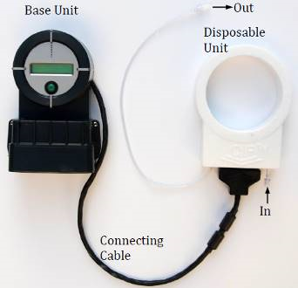

1. Y-Type Blood administration drop set

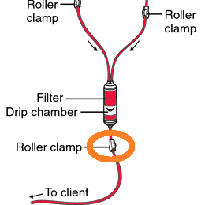

1. Whole Blood

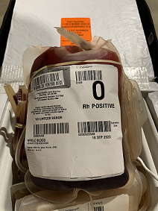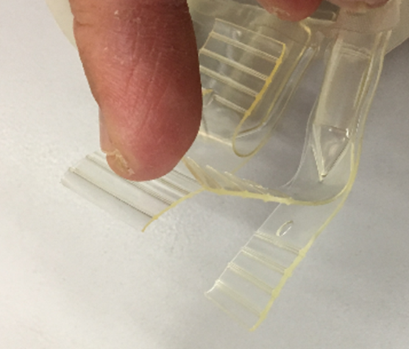  
(Close up of the Y-port used to spike the bag)

**Pediatric Considerations:**

1. Pediatric dosing is 10 – 20 ml/kg to start, titrated to effect
2. If administering products to a smaller pediatric patient, utilize a syringe for controlled and accurate dosing